SCIP – short manual

Synergic Crowd Innovation Platform can be entered via link: https://synergyplatform.pwr.edu.pl (Fig. 1). The platform is divided into three main sections (status 01/2020):
- Crowdfunding for research
- Crowdsourcing challenges for innovation
- Infrastructure sharing
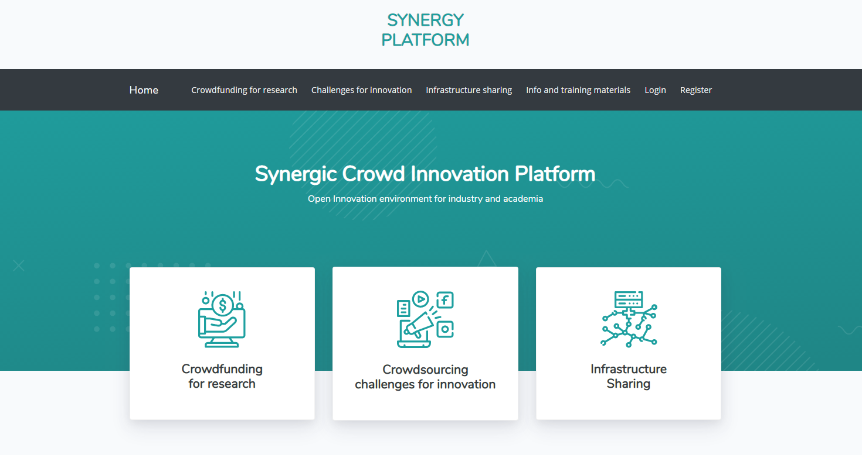
Fig. 1 Screenshot of Synergic Crowd Innovation Platform

The platform consist of:
- navigation bar
- main functionalities of platform (also accessible from navigation bar)
- List of last published campaigns and challenges
- Section about the project and latest news
- Section with term of use and contact.
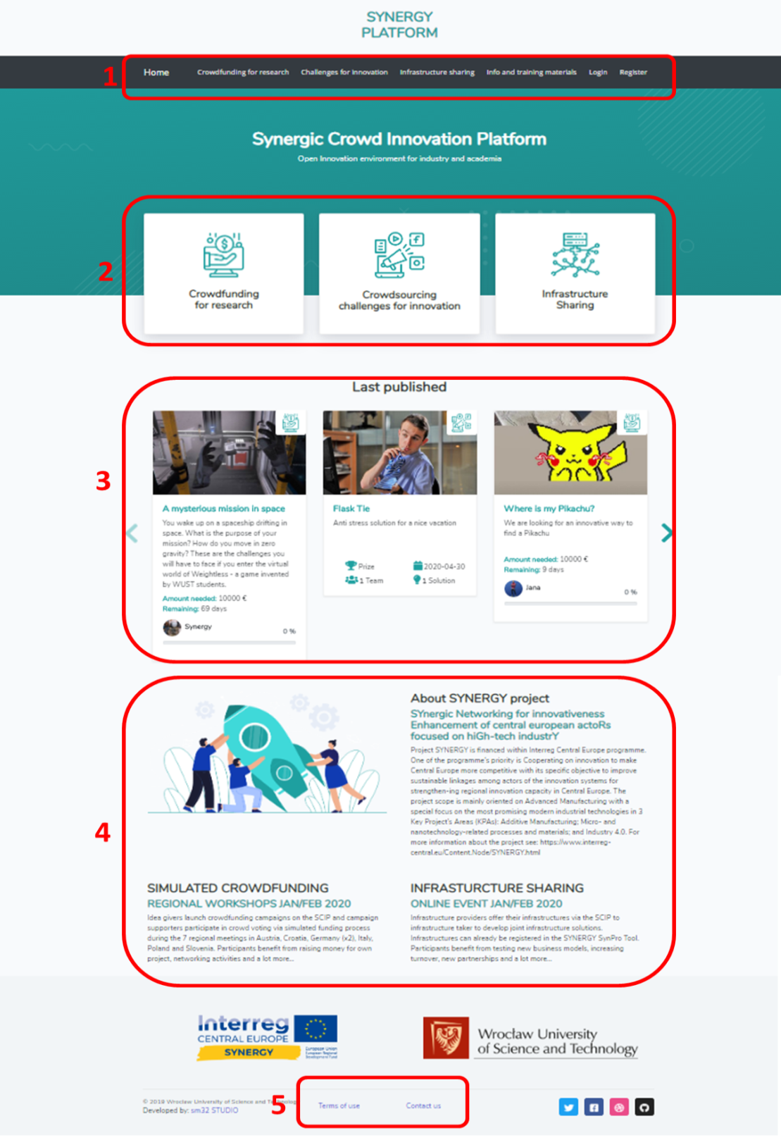
Fig. 2 Synergic Crowd Innovation Platform overview

  - Login / Registration and user’s profile
In the navigation bar after selecting the tab “Register” the application redirects to the view where user can create a new user account (Fig. 2). Having created an account, one can click on the tab “Login” where after completing login details user can log in to account (Fig. 3). Both login and registration is also possible using a Google account.

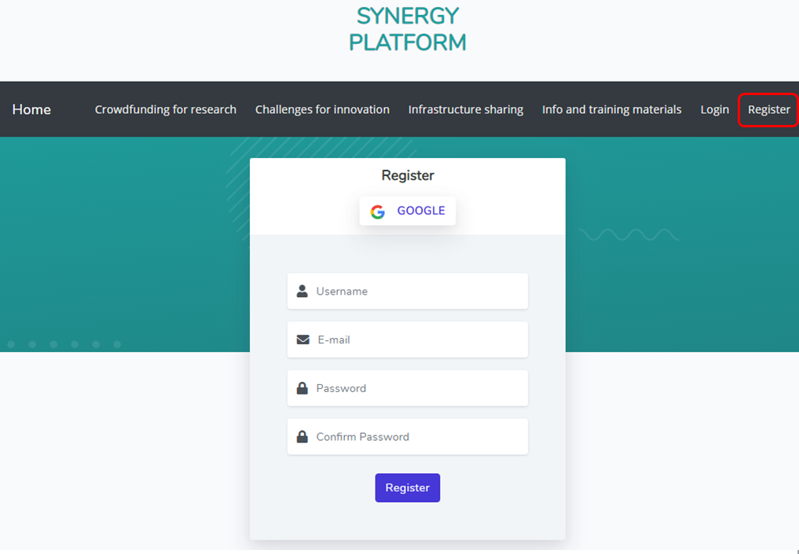
Fig. 3 Registering new account

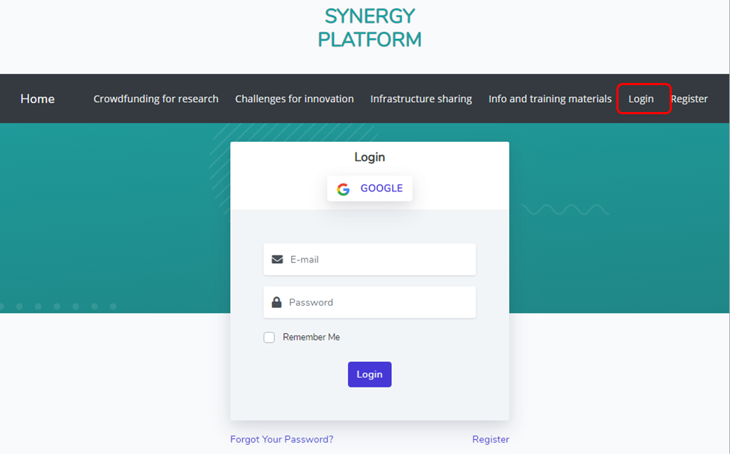
Fig. 4 Log-in to the platform

Logged in users can view their account details by clicking on the account avatar in the navigation bar and selecting “Profile” options and managing their data by selecting “Settings” (Fig. 4).
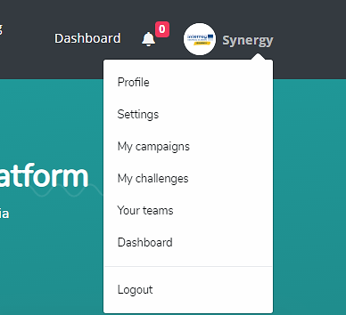
Fig. 5 Profile options for user account

Within different options of user account several sections can be entered:
- Profile – preview of the user’s profile (it also shows how other users will see this account)
- Settings – space for updating account information (Fig. 5)
- My campaigns – list of campaigns submitted by user
- My challenges – list of challenges submitted by user
- Your teams – list of teams that user belongs to
- Dashboard – space for users with appropriate permissions (administrator, authorizer, content moderator)
- Logout

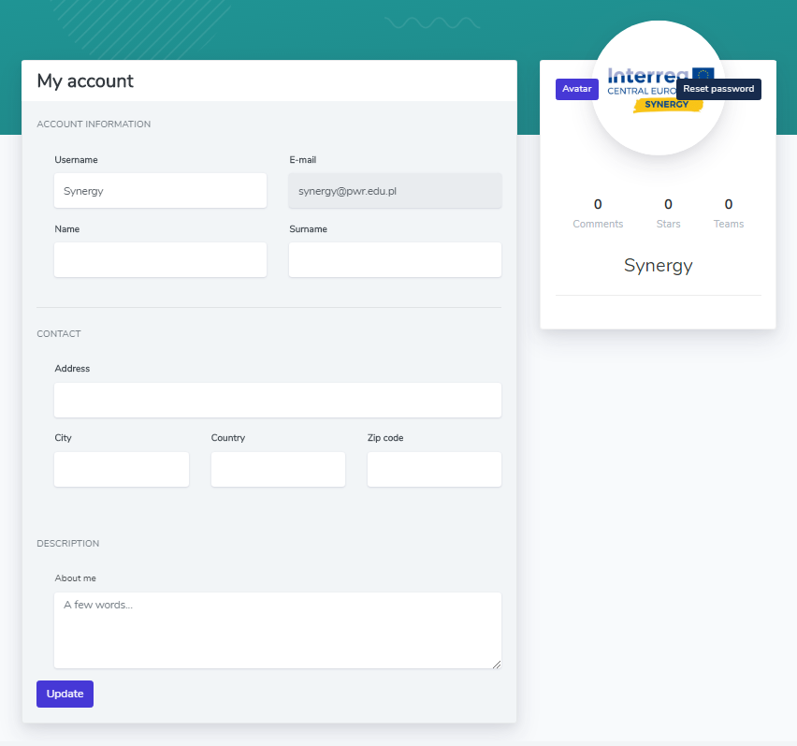
Fig. 6 Settings preview for updating user’s profile

  - Functionality: Crowdfunding for research
In the navigation bar after selecting the tab “Crowdfunding for research” the application redirects to the view where the list of active crowdfunding campaigns can be seen. In general, the user may be interested in following paths (Fig. 6):
- to add new crowdfunding campaign,
- to browse campaigns submitted by other users,
- to sort by publication date or campaign end date,
- to search for campaigns by key words.
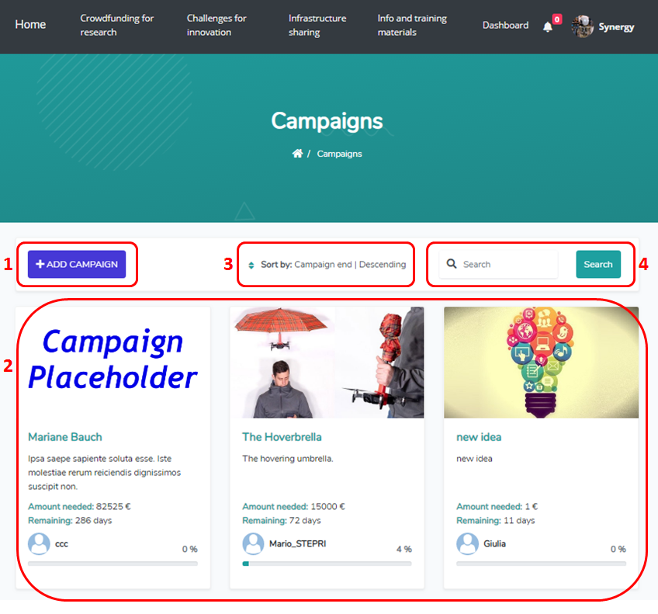
Fig. 7 Paths within “Crowdfunding for research” functionality

    - Adding new campaign
The user that is logged-in can add a new campaign by clicking the button “Add campaign”', then a pop up will appear with a form where the details about the campaigns should be filled in. There is a possibility to save the form as a “Draft version” (not all of the information has to be provided). The finished version of the campaign’s information form shall be submitted as “Released version” where all required data have to be filled in (otherwise submitting is not possible) (Fig. 7).
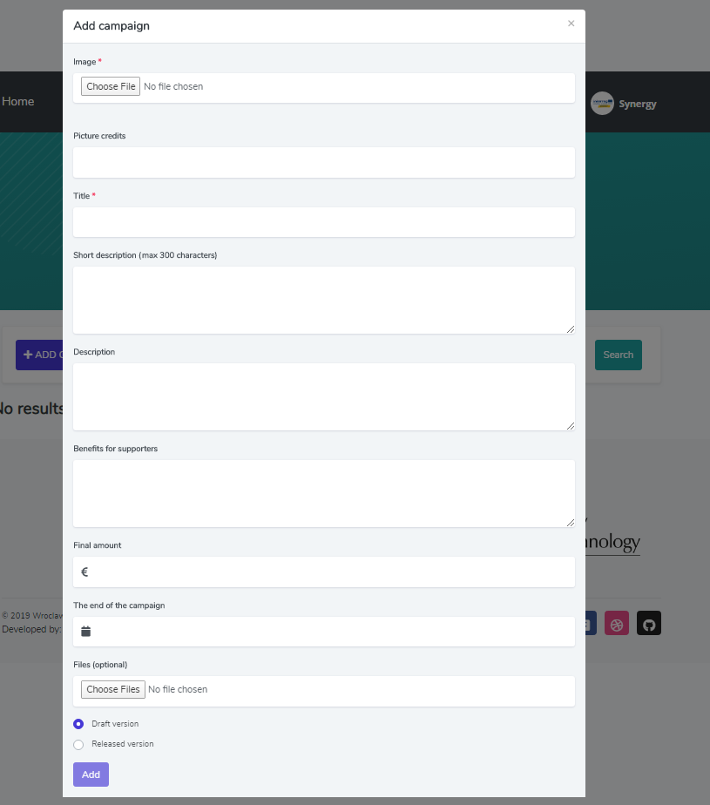
Fig. 8 Adding new crowdfunding for research campaign

After saving the campaign is registered but not yet approved – the information about “campaign inactive” is provided (Fig. 8), and a notification will be sent to platform administrators informing about new campaign. The administrator will verify the campaign’s content and will approve it – after this the campaign will be visible on the campaign list in the “Crowdfunding for research” functionality.

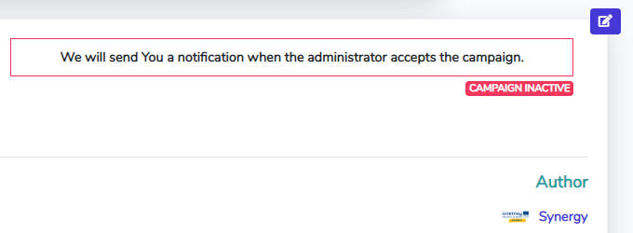
Fig. 9 Notification about inactive campaign

The “Released version' is visible in the list of campaigns within “user’s section”. To view all campaigns created on a given account, one has to click on the account avatar in the navigation bar and select option “My campaigns”.
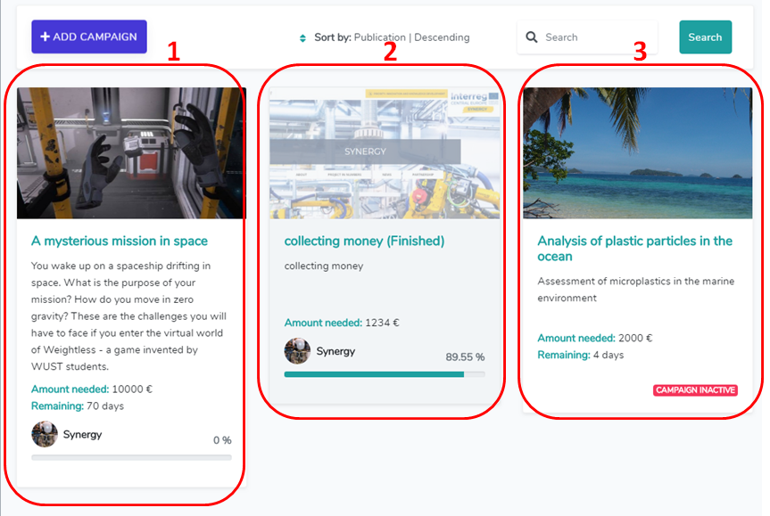
Fig. 10 Campaigns’ statuses

On the list of “My campaigns” different statuses of campaigns can be seen (Fig. 9):
- running campaign
- finished campaign
- inactive campaign

