Accelerating deployment and matureness of DIHs for the benefit of Digitisation of European SMEs
2022 #DIHWorld

DIH-WORLD Success story (from Slovenia):
AI-supported route optimization based on the IoT (Internet of Things) solution
Successful collaboration between the Jožef Stefan Institute (JSI) and company Senso4s d.o.o. (both from Slovenia).
Senso4s contacted DIH4JSI, which operates at the Center for Technology Transfer and Innovation (CTT) at the JSI, with the purpose of applying for an experiment within the DIH-World’s 1st Open Call for Experiment.
The proposal “AI-supported route optimization based on the IoT (Internet of Things) solution” was granted funding. DIH4IJS, as the project partner, connected the company with researchers from the Department of Knowledge Technologies and the Department of Intelligent Systems of the JSI, for the purpose of support and development of the software solution for optimizing delivery routes of gas cylinders based on the data collected from IoT devices.
The experiment consisted of two parts. In the first part, Senso4s upgraded their existing product, a Bluetooth-based smart scale for measuring gas level in gas cylinders to a NarrowBand-IoT-(NB-IoT)-based solution that allows remote monitoring of gas level and developed a prototype product.
In the second part of the experiment, Senso4s cooperated with JSI researchers who developed an algorithm that optimizes delivery routes for the distributors of gas cylinders. During the development, the key input data was simulated by Senso4s, while the solution was later evaluated using real data from the NB-IoT scales developed in the first part of the experiment.
The developed software for optimizing the delivery of new gas cylinders provides the recommended (quickest) route for the selected number of future delivery dates based on the data gathered from the NB-IoT smart scales. The optimized delivery route is obtained by minimizing the custom cost function that considers four factors relevant for end users, gas distributors and their carriers. The optimized route is visually displayed by clearly showing the starting point (distributors warehouse), intermediate stops and endpoint for carrier’s delivery day.
After successful testing of the hardware and software part of the entire solution in the controlled environment, Senso4s tested the solution in a real-world experiment. For this purpose, they distributed prototype smart scales to several end users across the wider Ljubljana area (Ljubljana City and its surroundings; Republic of Slovenia). They intentionally selected diverse locations and different gas cylinders used in order to cover as many use case scenarios as possible. For example, the locations included a secure building, a family home in the suburb with poor signal coverage, an industrial facility, a flat in the apartment building and a family home in the Ljubljana surrounding region; the gas cylinders applied were household LPG cylinders, cylinder with argon, cylinder with liquid nitrogen.
The testing results in the real-world environment showed some obstacles (e.g., the secure building had relevant bands intentionally disabled) but the measurements from the unproblematic locations were successfully fed into the developed prototype software.
The achieved results indicate that the project team reached all technical objectives set in the proposed experiment.

Details of the prototype product:
- Product dimensions:
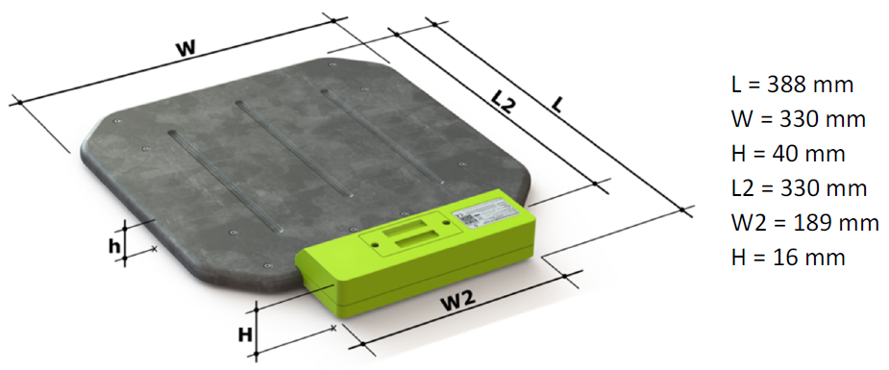

- Enclosure material: Plastic with steel sheet
- Power supply: 2x AA batteries (alkaline), 1.5 V
- Measurement range: up to 100 kg
- Mass measurement system: The same solution as implemented in the existing product of the SME. For more information, please visit https://www.senso4s.com/how-it-works/#How
- Communication technology: NB-IoT
- Antenna: SMD antenna tuned on LTE bands B8 and B20

For more information about the experiment (the success story) please write to tehnologije@ijs.si.
Thank you for your time to read this article!

8. 4. 2022

