Date | 15/06/2023 |  |  | Deadline | 19/09/2023… | …

CONTACT

Organisation | CEA | Department | UMR1292 INSERM-CEA-UGA
Contact person | Odile FILHOL | Email | Odile.filhol-cochet@cea.fr
City | Grenoble | Website | Laboratoire Biologie et Biotechnologie pour la Santé - Équipe Mécanismes d'Invasion en Angiogenèse et dans le Cancer (IMAC) (biosante-lab.fr)
Country | FRANCE

Organisation type

Research organisation type | Research Organisation  University  Company  Other | Is your company a Small and Medium Sized Enterprise (SME*)?  Number of employees: | YES NO

Your enterprise is an SME if:
- it is engaged in economic activity
- it has less than 250 employees
- it has either an annual turnover not exceeding €50M, or an balance sheet total not exceeding €43M
- it is autonomous
For the definition of SMEs, look at: http://ec.europa.eu/growth/smes/business-friendly-environment/sme-definition_en

Short introduction of key areas of institute’s research:

Former participation in an FP European project?  Project title / Acronym:  Activities performed: | YES NO  KATY  Partner

Expertise / Commitment offered

 | Description of your expertise: | 3D cultures (tumoroids and tissue slice culture) derived from kidney cancer associated with protein kinase inhibitors validation.
 | Keywords specifying your expertise: | Renal cell carcinoma, metastasis, Tumour slice culture, kinase inhibitor.
 | Commitment offered: | Research Demonstration Training  Technology Dissemination Other:

Interested in participation in project types: | Research & Innovation Action | Innovation Action | SME Instrument

Work Programme research areas: indicate your interest

Proposal: ONCOTRAP: A Microfluidic Chip to mimic metastatic process
UMR1292 Biosanté

The metastatic spread of cancer cells is a complex multi-step process, responsible for 90% of cancer-related mortality. Faced with this major challenge in oncology, it is therefore urgent to develop experimental models that mimic tumor environments and metastatic niches. Bone represents a critical site for the development of metastases that can occur in up to 40% of patients with kidney cancer during their lives. Unfortunately, in vitro models allowing the detection of metastatic cancers and the optimization of appropriate treatments are still not enough biomimetic to give an accurate response without artifact due to the in vitro cultures. Microfluidic-based in vitro models emerge as powerful alternatives to animal testing, as well as promising tools for the development of personalized medicine solutions.
- Project objectives and description of the methods, which will be used to achieve them.
The objective is to create a biomimetic model of kidney cancer metastasis to bone, liver or lung. For this purpose, we develop a microfluidic device to: 1) define the experimental conditions allowing the egress and dissemination of cancer cells from patient-derived tumors, 2) study their tropism for a specific environment, 3) evaluate the aggressiveness of patient-derived tumors and analyze the omic profiles of metastatic cells, 4) test anti-metastatic drugs.
- Expected results
From a fundamental point of view, a better knowledge of metastatic renal cell requirement and information on the cross talk between kidney cancer cells and the metastatic niches. Hence, a sensitive, accurate and cost-effective technique for predicting a tumor’s metastatic potential is needed. A microfluidic device will be used to identify new treatments to fight metastasis and hopefully as a future tool to facilitate decisions regarding patient management in the context of personalized medicine.

Partners identified:

CEA - Saint Louis Hospital, Joël Le Maoult: Immunotherapy in renal cancer
- CMBA, the bioinformatics and AI expertise of the MODAL group makes it possible, through computer modeling of transcriptomic data, to compare the molecular and cellular similarity between 3D cell cultures and tissues and to investigate the mechanisms of action of drugs.
UK - USTAN University of St Andrews, David Harrison, Analysis of histological images of renal cancer, application of image analysis tools and derivation and validation of algorithms using statistics and machine learning.
- UEDIN - University of Edinburgh, Alexander Laird, Providing expertise on RCC patients (data basis, clinical requirements and scenarios)

Partners requested:

Microfluidic experts who could be in compagnies.
Experts in lung and liver metastatic niches.
Long-term video-microscopy experts.
European urologists and Social health society.

The metastatic spread of cancer cells is a complex multi-step process, responsible for 90% of cancer-related mortality. Faced with this major challenge in oncology, it is therefore urgent to develop experimental models that mimic tumor environments and metastatic niches. Bone represents a critical site for the development of metastases that can occur in up to 40% of patients with kidney cancer during their lives. Unfortunately, in vitro models allowing the detection of metastatic cancers and the optimization of appropriate treatments are still lacking. However, microfluidic-based in vitro models emerge as powerful alternatives to animal testing, as well as promising tools for the development of personalized medicine solutions.
- Project objectives and description of the methods, which will be used to achieve them.
The objective is to create a biomimetic model of kidney cancer metastasis to bone, liver or lung. For this purpose, we develop a microfluidic device to: 1) define the experimental conditions allowing the egress and dissemination of cancer cells from patient-derived tumors, 2) study their tropism for a specific environment, 3) evaluate the aggressiveness of patient-derived tumors and analyze the omic profiles of metastatic cells, 4) test anti-metastatic drugs.
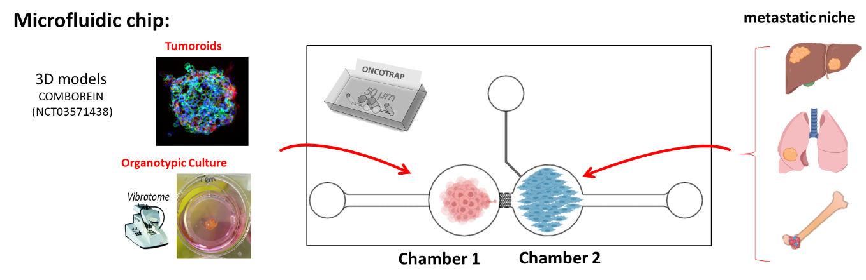
- Expected results: From a fundamental point of view, a better knowledge of metastatic renal cell requirement and information on the cross talk between kidney cancer cells and the metastatic niches. Hence, a sensitive, accurate and cost-effective technique for predicting a tumor’s metastatic potential is needed. Our microfluidic device will be used to identify new treatments to fight metastasis and hopefully as a future tool to facilitate decisions regarding patient management in the context of personalized medicine.
- Preliminary results : The first prototype of the microfluidic device has been fabricated and Partner 1 has already observed the capability of migration of a spheroid from 786-O kidney cancer cells if attracted by the higher serum concentration present in the other compartment (Figure a). In co-culture experiments, we have also shown that tumor cells (786-O spheroids) strongly interact with differentiated bone cells by forming a complex network, while on undifferentiated cells the spheroids remain compacted (Figure b). 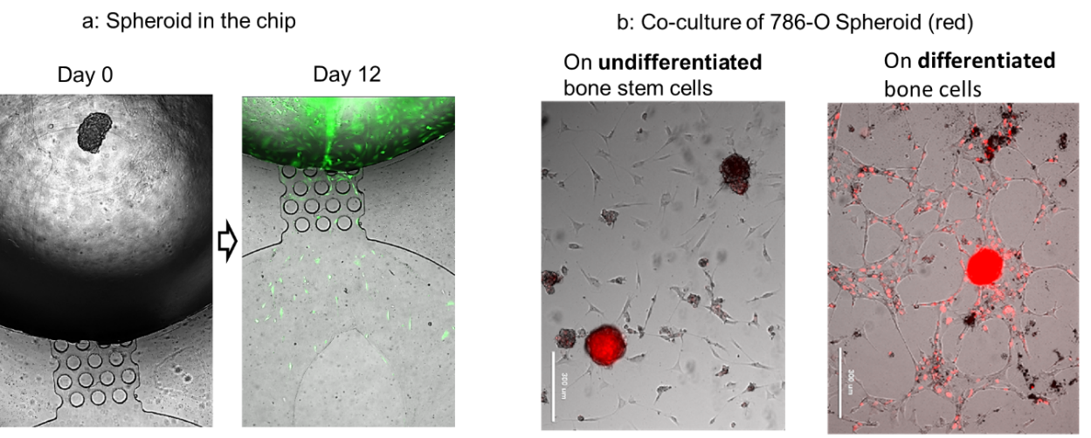
Figure: a, 786-O spheroid placed in chamber 1 at day 0 and day 12, lived cells were labeled with calcein (in green). b,co-culture of human periosteoum derived stem cells differentiated on biomaterials for 2 weeks and placed in contact with a m-Cherry-labeled 786-O spheroid (red staining) for 3 days.

Call topic(s):
https://www.horizon-europe.gouv.fr/innovative-non-animal-human-based-tools-and-strategies-biomedical-research-33847

Do you have other partners for this topic (which partners/country)? | David Harrison (UK,Saint Andrews), Analysis of histological images of renal cancer, application of image analysis tools and derivation and validation of algorithms using statistics and machine learning.
 | Alexander Laird (UK, Edinburgh), Providing expertise on RCC patients (data basis, clinical requirements and scenarios)
 | Håkan Axelson, Sarah Schoch (Sweden, Lund) Bioinformatic analyses of genomic/transcriptomic data. Experimental systems for assessment of predicted therapy based on organoid modeling.

Profile of partner sought

Role | technology development | research | training
 | dissemination | demonstration | other ______________
Country /region
Expertise required | Microfluidic / Liver and/or Lung metastatic niche.

I agree with the publication of this document and my contact data: YES NO

